소프트웨어분석설계

Team3 Project

2020.12.10

|  |  |
| --- | --- |
| 학번 | 성명 |
| 2019315010 | 강영미 |
| 2019315026 | 전유정 |
| 2019315027 | 최서연 |
| 2019315036 | 허다희 |

The library has a name, holds a number of books each of which has a title, author and unique catalogue number. There are registered borrowers each with a unique name. A borrower may borrow a book and return it. However, each book transaction must be recorded by a librarian. She is also expected to register a new borrower, be able to display in increasing catalogue number order those books available for loan and those already out on loan.

1. Library Application의 6개 Use Case에 대한 Sequence Diagram(총6개)을 작성하시오.

2. Library Application의 Class Diagram을 작성하시오.

**<Sequence Diagram 1: 새로운 이용자를 등록한다.>**

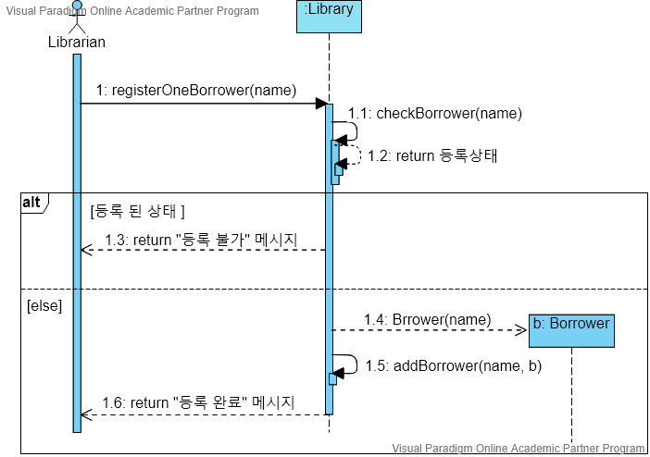

**<Sequence Diagram 2: 새로운 책을 등록한다.>**

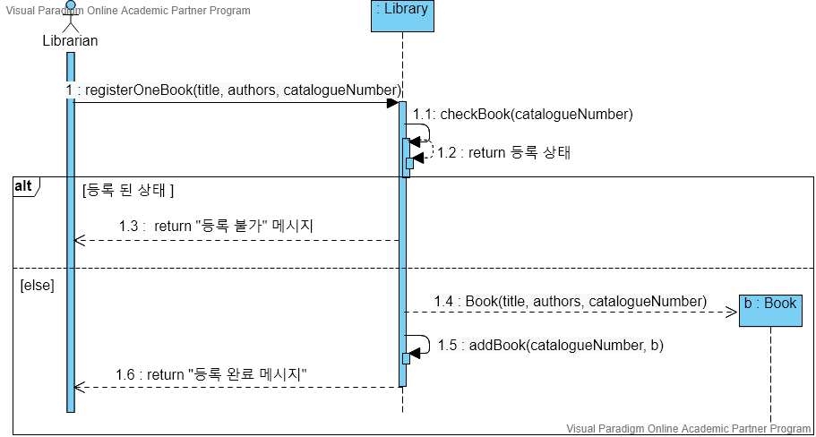

**<Sequence Diagram 3: 대출 가능한 책들을 화면 출력한다.>**

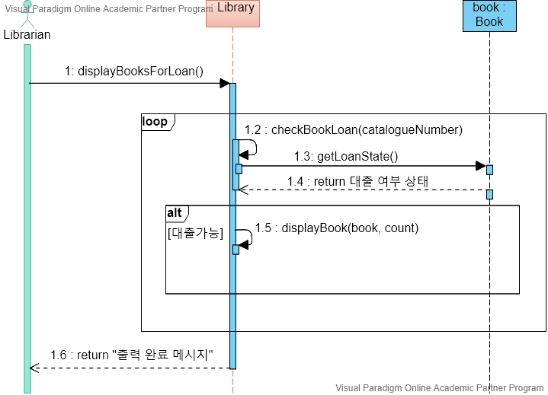

**<Sequence Diagram 4: 대출 중인 책들을 화면 출력한다.>**

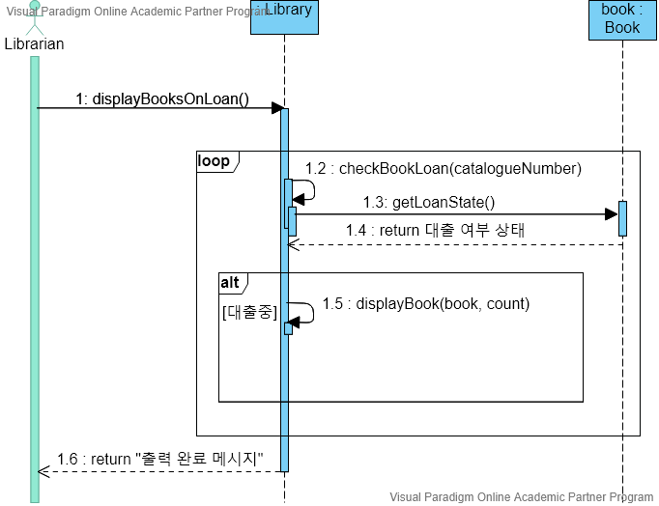

**<Sequence Diagram 5: 책을 대출한다.>**

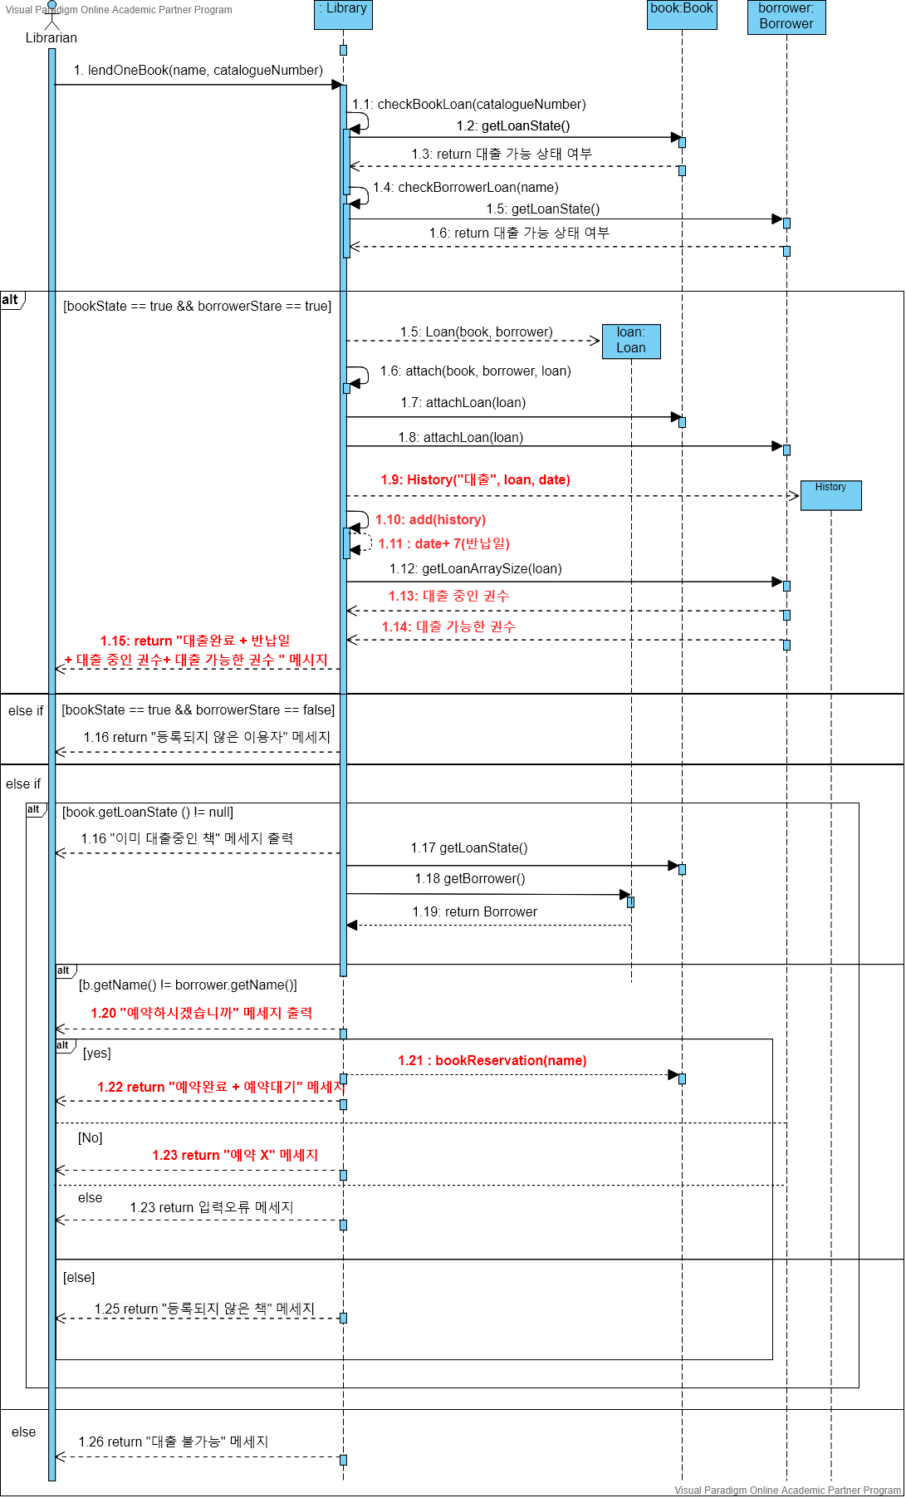

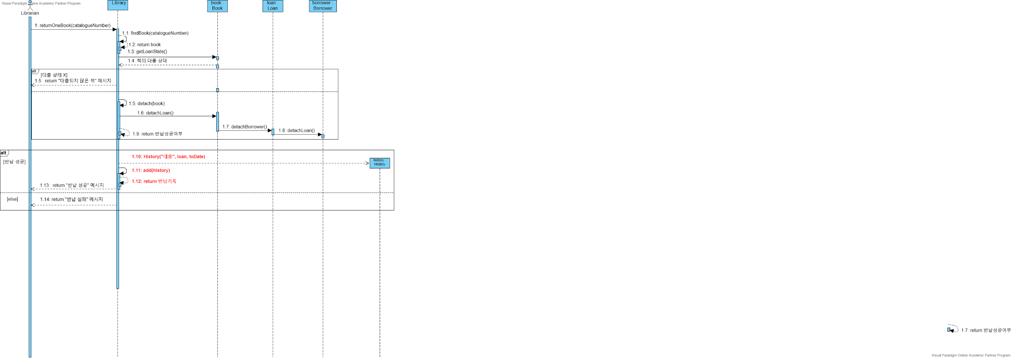**<Sequence Diagram 6: 책을 반납한다.>**

**<Class Diagram: Library Application>**

